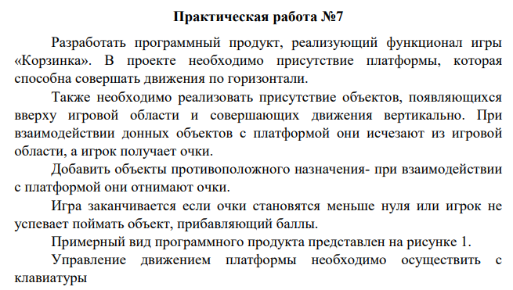

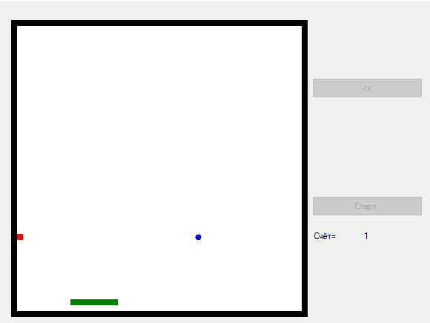

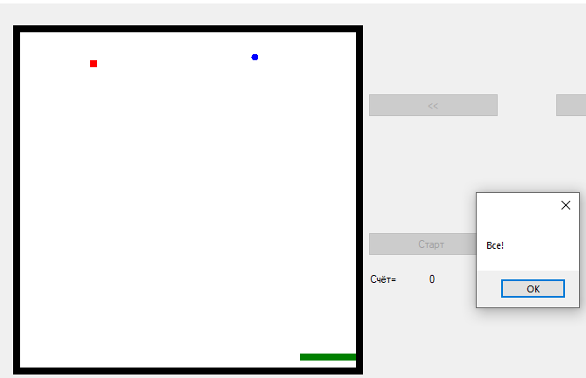

Form1.cs

public partial class Form1 : Form

{

Game g;

public Form1()

{

InitializeComponent();

}

private void Form1_Load(object sender, EventArgs e)

{

pictureBox1.Image = new Bitmap(pictureBox1.Width, pictureBox1.Height);

this.Focus();

}

private void button1_Click(object sender, EventArgs e)

{

if (g.Move(1) == false)

{

MessageBox.Show("Конец игры!");

}

}

private void button4_Click(object sender, EventArgs e)

{

if (g.Move(2) == false)

{

MessageBox.Show("Конец игры!");

}

label2.Text = g.count.ToString();

}

private void button5_Click(object sender, EventArgs e)

{

g = new Game(pictureBox1);

button5.Enabled = false;

timer1.Start();

}

private void button2_Click(object sender, EventArgs e)

{

g.Move(4);

}

private void button3_Click(object sender, EventArgs e)

{

g.Move(3);

}

private void timer1_Tick(object sender, EventArgs e)

{

g.MoveFood2();

bool f=g.MoveFood();

label2.Text = g.count.ToString();

if (f == false)

{

timer1.Stop();

MessageBox.Show("Все!");

}

}

private void Form1_KeyDown(object sender, KeyEventArgs e)

{

if (e.KeyCode == Keys.Up)

{

if (g.Move(1) == false)

{

MessageBox.Show("Все!");

button5.Enabled = true;

label2.Text = "0";

}

else label2.Text = g.count.ToString();

}

else if (e.KeyCode == Keys.Down)

{

if (g.Move(2) == false)

{

MessageBox.Show("Все!");

button5.Enabled = true;

label2.Text = "0";

}

else label2.Text = g.count.ToString();

}

else if (e.KeyCode == Keys.Right)

{

if (g.Move(3) == false)

{

MessageBox.Show("Все!");

button5.Enabled = true;

label2.Text = "0";

}

else label2.Text = g.count.ToString();

}

else if (e.KeyCode == Keys.Left)

{

if (g.Move(4) == false)

{

MessageBox.Show("Все!");

button5.Enabled = true;

label2.Text = "0";

}

else label2.Text = g.count.ToString();

}

}

}

MyPoint.cs

public class MyPoint

{

public int x, y;

public MyPoint(int n_x, int n_y)

{

x = n_x;

y = n_y;

}

}

Snake.cs

public class Snake : ParentClass

{

public int speed = 1;

public Snake(Color n_color) : base(n_color)

{

//color=n_color;

}

public void AddHvost() //добаввление хвоста

{

int n = body.Count - 1;

if ((body[n].x - body[n - 1].x) == 0)

{

body.Add(new MyPoint(body[n].x, body[n].y + 1));

}

else

{

body.Add(new MyPoint(body[n].x + 1, body[n].y));

}

}

public void Move(int dx, int dy) // движение змейки

{

//if (!(body[0].x - 1 < 0 || body[body.Count - 1].x + 1 > 50))

// {

if (dx == -1)

{

if (body[0].x - 1 >= 0)

{

for (int i = body.Count - 1; i > 0; i--)

{

body[i].x = body[i - 1].x;

body[i].y = body[i - 1].y;

}

body[0].x = body[0].x + dx;

body[0].y = body[0].y + dy;

}

}

else

{

if (body[body.Count - 1].x + 1 < 49)

{

for (int i = 0; i < body.Count - 1; i++)

{

body[i].x = body[i + 1].x;

body[i].y = body[i + 1].y;

}

body[body.Count - 1].x = body[body.Count - 1].x + dx;

body[body.Count - 1].y = body[body.Count - 1].y + dy;

}

}

}

// }

}

ParentClass.cs

public class ParentClass

{

public Color color;

public List<MyPoint> body = new List<MyPoint>();

public ParentClass(Color n_color)

{

color = n_color;

}

public void Add(MyPoint p)

{

body.Add(p);

}

}

Food.cs

public class Food:ParentClass

{

public Food(Color n_color) : base(n_color)

{

}

public void Delete(int t)//удаление еды с экрана

{

body.RemoveAt(t);

}

public MyPoint RandomFood(int sx, int sy)//случайное появление еды

{

Random r = new Random();

MyPoint a = new MyPoint(r.Next(0, sx), 0);

return a;

}

public void Move()

{

for (int i = 0; i < body.Count; i++)

{

body[i].y = body[i].y+1;

}

}

}

Game.cs

public class Game

{

Snake my_snake = new Snake(Color.Green);

Food my_food = new Food(Color.Red);

Food my_food2 = new Food(Color.Blue);

Block my_block = new Block(Color.Black);

public int count = 0;

int l = 50;// Масштаб одного блока

Color pole = Color.White;

PictureBox myPb;

public Game(PictureBox n_myPb)

{

myPb = n_myPb;

LoadLevel(1);

RandomFood();

Show();

}

public void LoadLevel(int n)

{

StreamReader sr = new StreamReader(n.ToString() + ".txt");

int str = 0;

while (!sr.EndOfStream)

{

string s = sr.ReadLine();

for (int i = 0; i < s.Length; i++)

{

if (s[i] == '*')

{

my_block.Add(new MyPoint(i, str));

}

else if (s[i] == '$')

{

my_snake.Add(new MyPoint(i, str));

}

}

str++;

}

sr.Close();

}

public void EdaColision()

{

for (int i = 0; i < my_food2.body.Count; i++)

{

for (int j = 0; j < my_snake.body.Count; j++)

{

if (my_food2.body[i].x == my_snake.body[j].x && my_food2.body[i].y == my_snake.body[j].y)

{

my_food2.Delete(i);

count--;

//my_snake.AddHvost();

RandomFood();

}

}

}

for (int i = 0; i < my_food.body.Count; i++)

{

for (int j = 0; j < my_snake.body.Count; j++)

{

if (my_food.body[i].x == my_snake.body[j].x && my_food.body[i].y == my_snake.body[j].y)

{

my_food.Delete(i);

count++;

//my_snake.AddHvost();

RandomFood();

}

}

}

}

public void RandomFood()

{

MyPoint p = my_food.RandomFood(l, l);

my_food.Add(p);

Thread.Sleep(100);

MyPoint r = my_food2.RandomFood(l, l);

my_food2.Add(r);

Thread.Sleep(100);

}

public void Show()

{

int k = myPb.Width / l;

Graphics gr = Graphics.FromImage(myPb.Image);

SolidBrush cl = new SolidBrush(pole);

gr.FillRectangle(cl, 0, 0, myPb.Width, myPb.Height);

SolidBrush color_snake1 = new SolidBrush(Color.Purple);

SolidBrush color_snake = new SolidBrush(my_snake.color);

for (int i = 0; i < my_snake.body.Count; i++)

{

/*if (i == 0)

{

gr.FillRectangle(color_snake1, my_snake.body[i].x * k, my_snake.body[i].y * k, k, k);

}

else*/

{

gr.FillRectangle(color_snake, my_snake.body[i].x * k, my_snake.body[i].y * k, k, k);

}

}

SolidBrush color_block = new SolidBrush(my_block.color);

for (int i = 0; i < my_block.body.Count; i++)

{

gr.FillRectangle(color_block, my_block.body[i].x * k, my_block.body[i].y * k, k, k);

}

SolidBrush color_food = new SolidBrush(my_food.color);

for (int i = 0; i < my_food.body.Count; i++)

{

gr.FillRectangle(color_food, my_food.body[i].x * k, my_food.body[i].y * k, k, k);

}

SolidBrush color_food2 = new SolidBrush(my_food2.color);

for (int i = 0; i < my_food2.body.Count; i++)

{

gr.FillEllipse(color_food2, my_food2.body[i].x * k, my_food2.body[i].y * k, k, k);

}

myPb.Refresh();

}

public bool Move(int k)

{

bool a = true;

if (k == 1)

{

my_snake.Move(0, -1);

}

else if (k == 2)

{

my_snake.Move(0, 1);

}

else if (k == 3)

{

my_snake.Move(1, 0);

}

else if (k == 4)

{

my_snake.Move(-1, 0);

}

EdaColision();

a = Crush();

if (a == true)

{

Show();

}

return a;

}

public bool MoveFood2()

{

my_food2.Move();

EdaColision();

bool f = true;

for (int i = 0; i < my_food2.body.Count; i++)

{

if (my_food2.body[i].y > l)

{

f = false;

}

}

Show();

return f;

}

public bool MoveFood()

{

my_food.Move();

EdaColision();

bool f = true;

for (int i=0; i< my_food.body.Count; i++)

{

if (my_food.body[i].y > l)

{

f = false;

}

}

Show();

return f;

}

public bool Crush()

{

bool t = true;

for (int i = 0; i < my_block.body.Count; i++)

{

if (my_snake.body[0].x == my_block.body[i].x && my_snake.body[0].y == my_block.body[i].y)

{

t = false;

break;

}

}

for (int i = 1; i < my_snake.body.Count; i++)

{

if (my_snake.body[0].x == my_snake.body[i].x && my_snake.body[0].y == my_snake.body[i].y)

{

t = false;

break;

}

}

return t;

}

}

Block.cs

public class Block : ParentClass//класс для препядствия

{

public Block(Color n_color) : base(n_color)

{

}

}

Food2.cs

public class Food2:ParentClass

{

public Food2(Color n_color) : base(n_color)

{

}

public void Delete() //удаление еды с экрана

{

}

public MyPoint RandomFood(int sx, int sy)// Случайное появление еды

{

Random r = new Random();

MyPoint a = new MyPoint(r.Next(0, sx), 0);

return a;

}

public void Move()

{

for (int i = 0; i < body.Count; i++)

{

body[i].y = body[i].y + 1;

}

}

}

Ссылка на гитхаб:

<https://github.com/Alexandrov911/Practical7.2022.git>